Git Assignment Objective: The goal of this assignment is to help you get familiar with basic Git commands and workflows, which are commonly used in real-world software development.

1. Create a New Repository. (done -github repo)

2. Create a New File (done)

3. Create a Branch (done)

4. Make Changes in the New Branch(done)

5. Create Another Branch (Optional)(done)

6. Merge Branches(done)

7. Pull Changes from Remote(done as well as push)

8. View Git Log and History

Used git log –oneline for crisp output in a single line.

Used git –all to see all history from others branches, not just main branch.

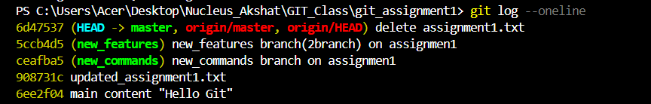

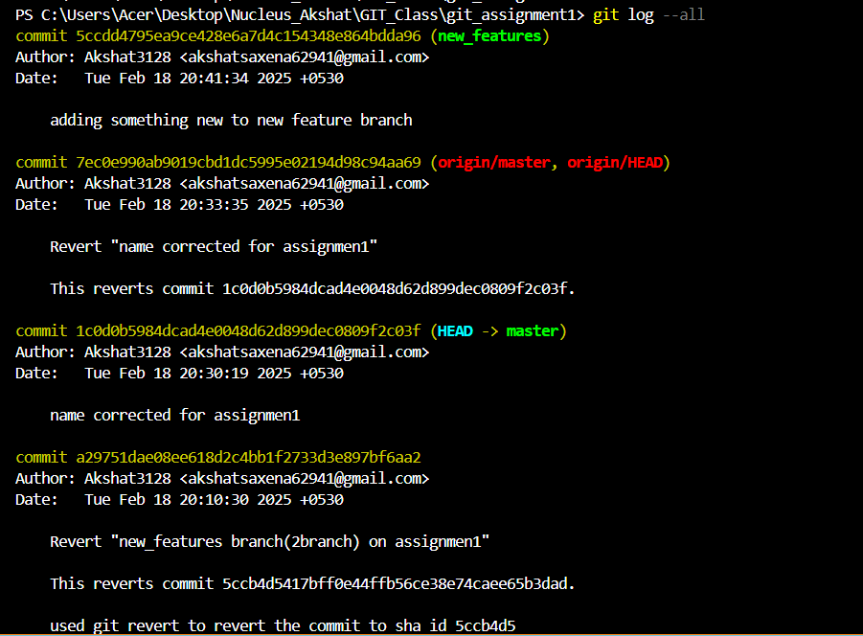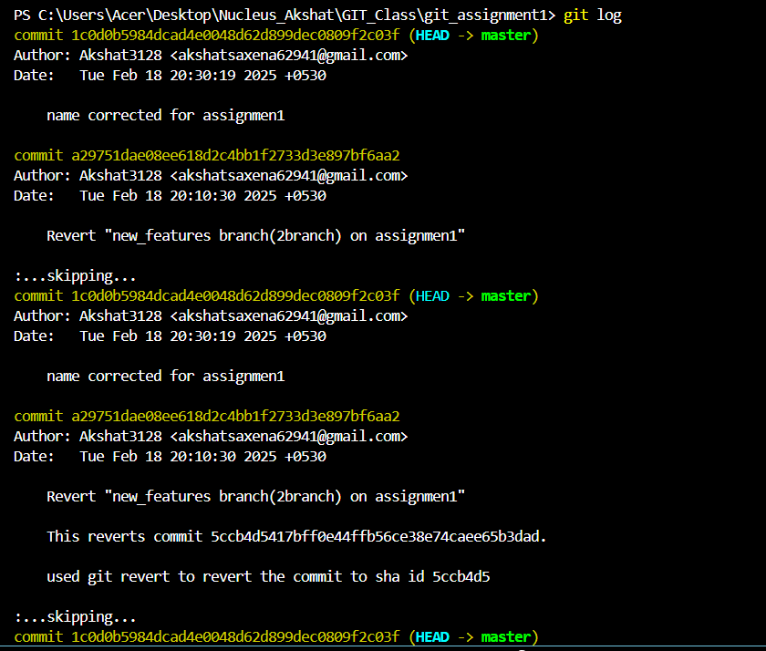­­

9. Git Status and Staging

10. Revert and Reset



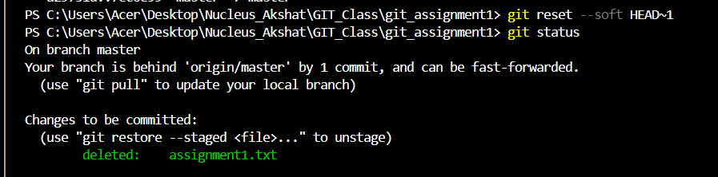

used git reset –soft to undo the last commit while keeping changes –hard can be used to remove changes which can be seen as my local repo is lagging the master repo by 1 commit